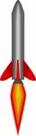
Rocket Science and Technology 4363 Motor Ave., Culver City, CA 90232
Phone: (310) 839-8956 Fax: (310) 839-8855

Flight Path Angle Dispersions (rev.1) 08 May 2011

By C. P. Hoult

Introduction
“Dispersion” can take on several, distinct meanings within engineering. Here, we mean the errors in trajectory state vector at a specific time, or errors in a defined event, e.g., apogee or impact. Errors are usually, but not always, described in statistical terms, e.g., the mean value of altitude 30 seconds after second stage ignition. Dispersions can be, and often are, a major concern in mission planning and flight operations. For example, post impact payload recovery planning is contingent upon good prior knowledge of the likely impact point location.

For sounding rockets, all dispersions act to either rotate the velocity vector or to change its length (energy). Sounding rockets tend to fly nearly vertically. It follows that their apogee errors mainly arise from energy errors while their impact errors are principally due to velocity vector rotations. At launch, there are no dispersions because we know where the launch site is. As perturbations continue to act, dispersions gradually build up with the passage of time. However, it is convenient to assess the trajectory state after all the perturbations have acted, and for those perturbations that rotate the velocity vector, define an equivalent launcher angle that would produce the same effect.

There are two prime perturbations that rotate the velocity vector, thrust misalignment¹ and wind gusts². These both excite the both rocket modes, the short period and the phugoid (trajectory). The essential short period response does not cause the rocket center of mass to move much. Rather, it excites angle of attack rotations about the C. M.. For this reason, short period motion is very important for structural loading, but of secondary importance to trajectory dispersions. In contrast, the phugoid mode response has very modest angle of attack motions but large center of mass motions. It is the phugoid, then, that describes trajectory dispersions. The key idea here is to take existing short period analyses for thrust misalignment and gusts, obtain their behaviors at points remote from the launcher, and assuming that most oscillations have been damped out, find the implied trajectory rotations.

One more element of the dynamics story needs mention, and that is the distinction between body-fixed and earth-fixed perturbations. Thrust misalignment is, at its roots, a conflation of structural misalignments that rotates with the body while the wind field, including gusts, is the quintessential earth-fixed perturbation. For both perturbations, the greatest velocity vector rotations occur at very low altitude. Thus, the prolonged constraint provided by a longer launch rail reduces dispersions.

Finally, this analysis is expected to be conservative; i.e., it will probably overestimate impact point errors. The thrust misalignment response is approximated by its steady state value. The actual transient response never has time to reach its steady state value. Similarly, the low altitude gust response is represented by its long term asymptote. In fact, at low altitudes the response is mostly less than the long term asymptote.

Nomenclature
________Mnemonic_____________________Definition_________________________
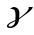 Standard deviation in flight path angle from the
vertical down to the velocity vector
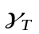 Standard deviation in one component of the
dispersive flight path angle due to thrust
misalignment
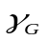 Standard deviation in one component of the flight
path angle due to wind gusts
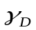 Dispersive flight path angle = vector amplitude of
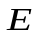 Easterly component of the dispersive flight path angle
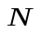 Northerly component of the dispersive flight path angle
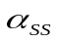 Steady state standard deviation in angle of attack due to
thrust misalignment
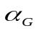 Standard deviation in gust angle of attack
 Roll angle
 Thrust
Distance from nozzle throat to center of mass
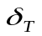 One component of the thrust misalignment angle
between the thrust vector and the rocket axis of
symmetry
 One component of the lateral offset of the center of
mass from the thrust vector
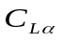 Lift coefficient slope
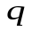 Dynamic pressure
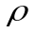 Atmospheric mass density
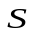 Aerodynamic reference area
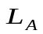 Aerodynamic lift force
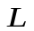 Launcher length
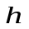 Altitude
 Vertical flight velocity
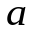 Acceleration along the flight path
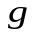 Acceleration due to gravity
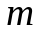 Rocket mass
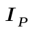 Rocket pitch moment of inertia
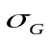 Standard deviation in planar gust velocity
________Mnemonic_____________________Definition_________________________
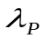 Pitch wave number
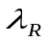 Roll wave number
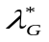 Pseudo gust correlation wave number

Thrust Misalignment Analysis
Dynamically, neglecting the short period damping per ref. 1 does not have a great effect on angle of attack estimates. But, one of the neglected terms, 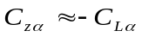, provides the only mechanism, apart from gravity, for rotating the velocity vector. So, in order to estimate the flight path angle response, we neglect short period damping to estimate the steady state angle of attack, but retain aerodynamic lift to estimate the flight path angle. Specifically, neglect thecontribution to the high frequency part of the solution in which the velocity vector has not the time to rotate significantly while retaining it for the low frequency part of the solution for which there is enough time for significant rotation..

It can be easily shown that a transient analysis for the angle of attack response can be obtained in terms of Fresnel integrals. Even though damping has been neglected in deriving short period solutions, it’s still there. We assume short period damping will act promptly (in the phugoid time frame) to suppress any oscillations. The approach used here is to assume the steady state angle of attack is immediately attained upon departing the launcher. With this simplification, an approximate flight path angle solution can be easily found. However, the need to numerically integrate to resolve the flight path angle response into northerly and easterly components remains.

Next, there are two sources for the normal force causing the flight path angle to change, gravity and aerodynamic lift. The normal force due to thrust misalignment itself can be neglected because, while the thrust misalignment is in pitching moment equilibrium with the aerodynamic lift, the aerodynamic moment arm, the static margin, is must less than the thrust misalignment moment arm, the distance from nozzle throat to the c.g.

Reference1 derives the steady state angle of attack response for a rolling sounding rocket accelerating in vertical flight. Its treatment of the steady state response follows the lines laid down in ref. 2 which addressed the analogous problem for aircraft flying at constant speed. The adaptation to accelerated, time-varying, response of a rocket is documented in ref. 3.

Now, start with the steady state angle of attack as given by eq. (16) of ref. 1:

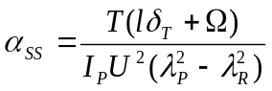 (16)

It is important to note that the perturbing effects, and , are statistical in nature. See ref. 5 for data on these parameters. If these be taken at the standard deviation level, their sum in eq. (16) above must be replaced by 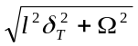 to generate at the standard deviation level. The resulting lift (a constant) is

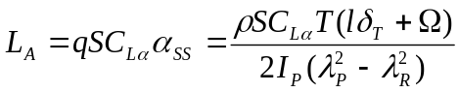 (2)

Now, use the methods of ref. (2) to write

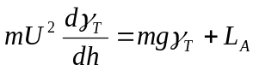, or
(3)
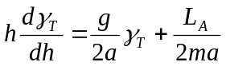,

subject to the initial condition that 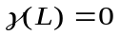.
The solution is
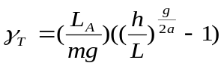 (4)

Figure 1 below shows a typical plot of eq. (4) when 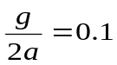. Note that most of the velocity vector rotation happens at low speed and altitude.

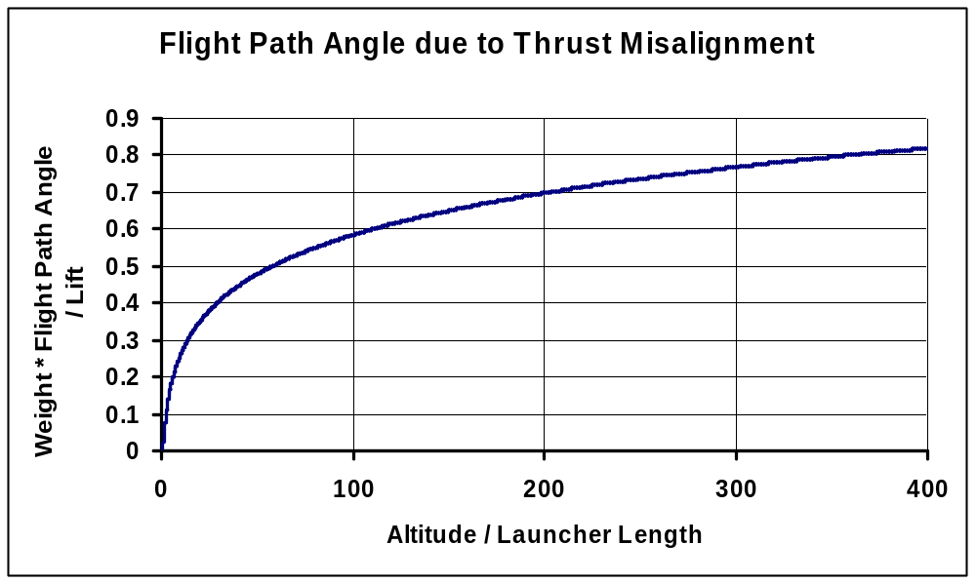
Figure 1 Flight Path Angle due to Thrust Misalignment

If the rocket did not roll, Fig. 1 would show a typical boost phase flight path angle history. But, flight path angle is, in fact, a vector quantity. That is, it has both a northerly component and an easterly one as well. Thus, in time 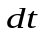the change in flight path angle 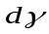can be resolved into its northerly and easterly components, and.

Now, look at Fig. 2. The northerly component of flight path angle is

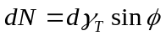,

and the easterly component is

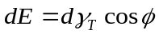.


N
E
Launcher

Figure 2

Recall from ref.1 the roll angle as a function of altitude is

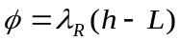 (5)
The process to be followed now is straightforward. We get from eq. (4) and the roll angle from eq.(5). Numerical integration using a simple Euler scheme develops theand components. A brief numerical study shows that three figure accuracy can be attained using an integration step size of 4 feet. Their root sum square generates their vector amplitude, called the dispersive flight path angle.
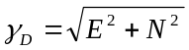 (6)

Since the thrust misalignment torque can have arbitrary roll phasing (it’s uniformly distributed with roll angle), the dispersive flight path angle is what’s needed to estimate impact point dispersion due to one component, say, in pitch, of the perturbing effects. Of course, there is a second, or yaw component, statistically independent, set of perturbing effects acting at right angles to the first and having the same standard deviation as the first. In the statistical sense, the easterly yaw displacement is the same as the negative of the northerly pitch displacement, and the northerly yaw displacement is the same as the easterly pitch displacement.
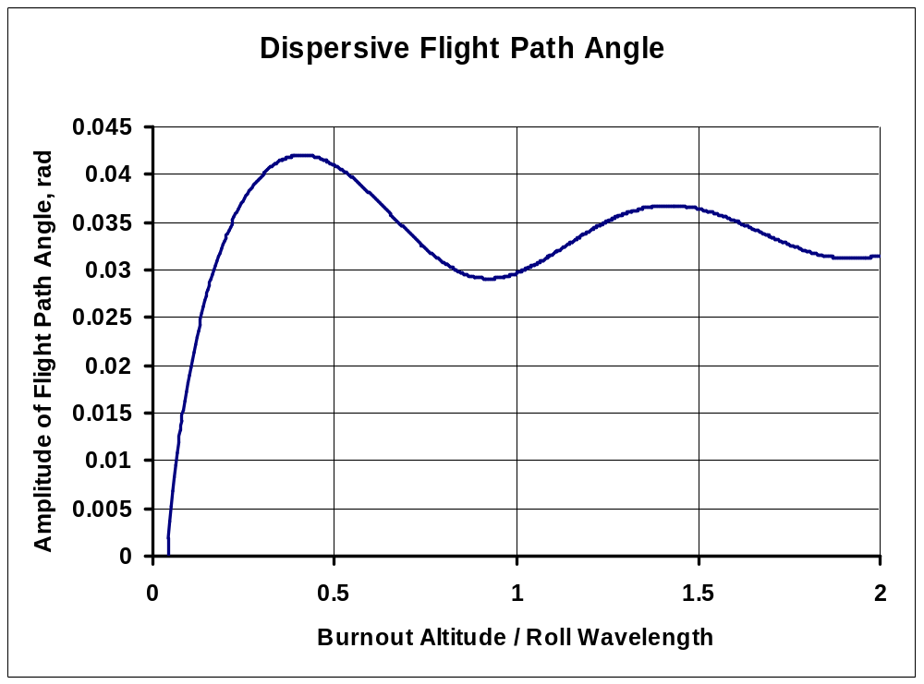
Figure 3 Typical Dispersive Flight Path Angle

The basis for Fig. 3 is , 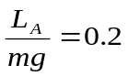 and 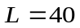feet. It clearly indicates the benefits of rolling an integer number of roll wavelengths during boost. It also shows that a single roll cycle provides the least dispersion, a characteristic of a wide variety of axial accelerations.

Wind Gust Analysis
Reference 6 documents the short period gust response statistics. The important conclusion to be drawn from ref. 6 is above the first correlation distance, the standard deviation in angle of attack is approximately constant. This insight can be used as the foundation of an approximate analysis of gust-induced phugoid motion.
Now, following eq. (18) of ref. 1 and assuming a nominally vertical trajectory,

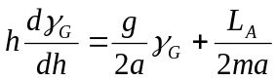. (18)

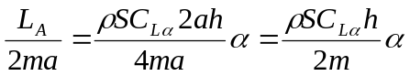,

where eq. (15) of ref. 6 gives
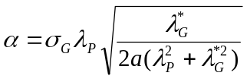. (15)

Here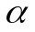 is the asymptotic value of the standard deviation in the gust angle of attack. Since the forcing function is at the standard deviation level, the flight path angle response is also at the same level. That is, if the aerodynamic liftis always at the standard deviation level, then the flight path angle will always be at the one standard deviation level.

After integration we have

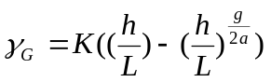 , where
(7)
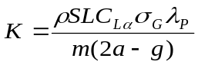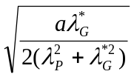.

Quantitative parameters needed to evaluate eq. (7) can be assessed from data in ref. 5. Equations (7) above describe the planar gust-induced flight path angle standard deviation.

Statistics
The last issue is that of converting a dispersive flight path angle to an impact point error. First, combine the thrust misalignment and wind gust errors. Since these arise from statistically independent causes, the planar standard deviation in flight path angle is

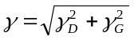 (8)

The flight path angle standard deviation in eq. (8) above will vary with time/altitude. It is suggested that foe purposes of trajectory dispersion analysis, that it be evaluated at burnout when all the thrust misalignment effects and nearly all the wind gust effects can be captured.

Suppose we could make a point mass trajectory simulation starting from

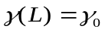 (9)

This would yield the impact range corresponding to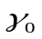. All that remains is to select to match the calculated burnout dispersive flight path angle as given by eq. (8). Refer now back to eq. (3) without any aerodynamic lift. Its solution is
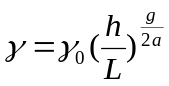, or
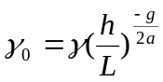 (10)

Here, evaluate and h at burnout using eq. (8) to find the planar standard deviation in flight path angle. Then, eq.(9) generates the initial condition for a point mass trajectory run to assess one component of the impact point displacement error.

The statistics of the problem merit some attention. First, we assume there are no biases. Wind gusts are known to have no mean value as documented in ref. (5). Next, we assume there are no known biases in and because the manufacturing and assembly processes used don’t have any. Next, a close examination of these same processes usually shows that each vector component of error effect (in body-fixed axes) arises as a sum of many smaller, independent effects, thus justifying the use of the central limit theorem. The two vector components of error are, by the same reasoning, mutually independent, as are and . Wind gust effects arise also from the sum of many small gusts with two mutually independent vector components. Finally, we unleash the power of the central limit theorem to assert that each component (north-south or east-west) of the impact point displacement error is normally distributed and independent of the other component.

Now, let’s explore the uses of this model. First, plug in some typical numbers and see how the effective launcher QE error,, varies with burnout altitude. As shown below, in this example, thrust misalignment has the most significant influence.
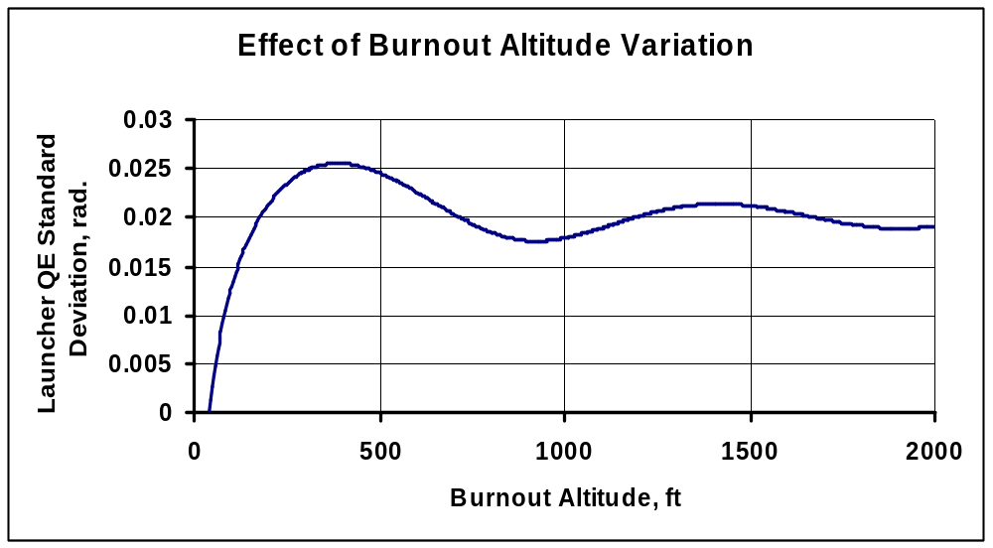

The two design variables that can be easily adjusted to vary this are and. Suppose that the burnout altitude were 1850 feet. The great beauty of working in a spread sheet is the rapidity with which design trade studies can be accomplished. For this case, the nominal results above were based on a roll wave length of 1000 feet and a pitch wave number of 0.015867 radians/foot. Extensive exploration has shown that the 1000 foot roll wave length is close to optimum over a broad band of pitch wave numbers. But, as sketched below, the pitch wave number makes a big difference!

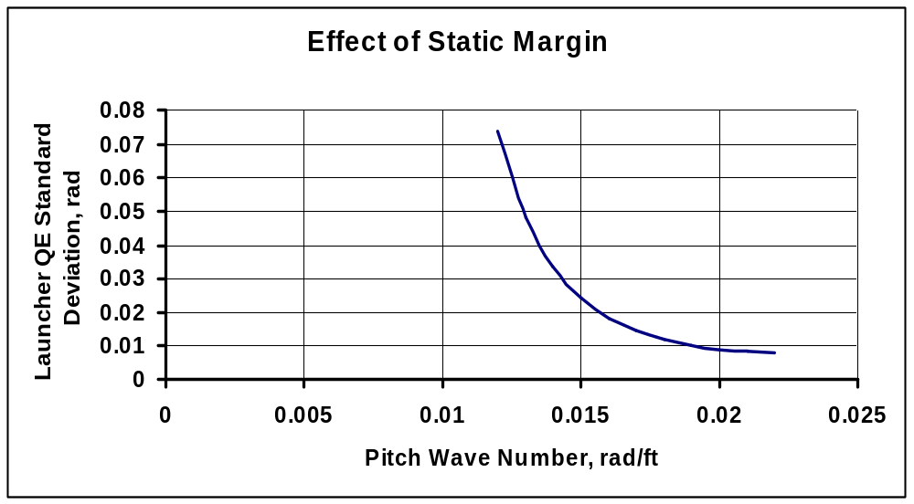

This displays a very interesting knee in the curve. That is, in this part of design space, more static margin can significantly reduce trajectory errors. The reader is cautioned however, to consider other consequences of bigger fins before revisiting the old drawing board (Yes, I know it’s all done in a computer these days.)

Finally, the above analysis is for a nominally vertical flight. These results can be adjusted for non-vertical flight per ref. (3), to create the product needed for mission planning and range safety.

References
- “Thrust Misalignment Response”, by C. P. Hoult, RST memo, 30 December 2010
- Phillips, W.H., “Effect of Steady Rolling on Longitudinal and Directional Stability”, N.A.C.A. TN 1627, 1948.
- Hoult, C. P., “A Simplified Ballistics Model for Sounding Rockets”, Proceedings of the Unguided Rocket Ballistics Conference, University of Texas at El Paso – Texas Western College, El Paso, 30 August – 15 September 1966
- Hoult, C.P., Camera Pod Drag Estimation”, RST memo, 08 December 2010.
- “Standardized Perturbation Values to be Used in the Calculation of Dispersion and Structural Loads”, by R. L. Ammons and C. P. Hoult, Aerojet-General Corporation memo 8110:M0658:ak, 16 September 1970
- “Sounding Rocket Gust Angle of Attack”, by C. P. Hoult, to be published in the Journal of Spacecraft & Rockets

